# **Front End Engineering-II**

Project Report

Semester-IV (Batch-2022)

Education learning platform

**Supervised By: Submitted By:**

Ms. Preenu Mittan Arnav Jain -2210991349

Arnav Garg - 2210991348

Azimusshan Khan - 2210991432

**Department of Computer Science and Engineering**

Chitkara University Institute of Engineering & Technology,

Chitkara University, Punjab

Institute/School  **Chitkara University Institute of Engineering and**

Name  **Technology**

Department **Department of Computer Science & Engineering**

Name

Programme **Bachelor of Engineering (B.E.), Computer Science &**

Name  **Engineering**

Course **Front-end Engineering-II** Session **2023- 2024**

Name

Course  **22CS014**  Semester/ **4th /2022**

CodeBatch

Vertical **i** **Beta cluster** Group No **G17**

Name

**Table Of Content**

|  |  |  |
| --- | --- | --- |
| S.No. | Contents | Page No. |
| 1 | Introduction | 5-8 |
| 2 | Problem Definition and Requirements | 8-10 |
| 3 | Results | 10-11 |
| 4 | Conclusion | 12 |

**Sections**

1. **Introduction**

1.1 Abstract

1.2 Objective

1.3 Significance

1.4 Scope

2. **Problem Definition and Requirements**

2.1 Problem Statement

2.2 Requirements

2.2.1 Software Requirements

2.2.2 Hardware Requirements

3. **Methodology/ Workflow**

3.1 Website Making Steps

3.2 Technology Used

3.2.1 JSX & CSS

3.2.2 React JS

4. **Results**

4.1 Screenshots

5. **Future Scope And Enhancements**

6. **Conclusion**

**Introduction**

Introducing learnify, an innovative front-end educational learning platform designed to revolutionize the way students and educators interact with digital learning resources. Learnify offers a seamless, user-friendly interface that combines engaging multimedia content, interactive modules, and personalized learning pathways to cater to diverse educational needs. By leveraging the latest web technologies, the platform ensures a responsive and accessible experience across various devices, enhancing the learning journey from any location. Leanrify is dedicated to fostering a collaborative and immersive educational environment where learners can thrive, educators can efficiently manage courses, and both can track progress in real-time. With a focus on usability and adaptability, Learnify aims to bridge the gap between traditional education methods and the dynamic demands of modern learning.

**1.1 Abstract**

Learnify is a cutting-edge educational learning platform designed to transform digital education by providing an intuitive, engaging, and personalized learning experience. The platform integrates multimedia content, interactive modules, and adaptive learning pathways to meet the diverse needs of students and educators. Leveraging advanced web technologies, Learnify ensures a responsive, accessible, and user-friendly interface across all devices. It fosters a collaborative environment that supports real-time progress tracking and efficient course management. Learnify's mission is to bridge the gap between traditional education methods and the evolving demands of modern learners, creating a seamless and immersive educational experience for all users.

.

**1.2 Objective**

Learnify aims to revolutionize digital education by creating a user-friendly and interactive platform designed to enhance learning engagement and promote personalized learning. By integrating multimedia content, gamified elements, and adaptive learning pathways, Learnify tailors educational experiences to individual student needs and preferences. The platform fosters a collaborative learning environment through tools that encourage communication between students and educators. Ensuring accessibility and inclusivity, Learnify is designed to work seamlessly across various devices and comply with accessibility standards, benefiting all students, including those with disabilities. Educators are supported with robust course management tools that streamline content organization, student progress tracking, and feedback provision. Real-time analytics allow both students and educators to monitor performance and make data-driven decisions to improve learning outcomes. Committed to encouraging lifelong learning, Learnify provides resources that support continuous education and skill development. By leveraging advanced web technologies, Learnify ensures a responsive, scalable, and secure platform, adaptable to the evolving needs of modern education.

**1.3 Significance**

The significance of Learnify lies in its potential to transform the educational landscape by addressing the limitations of traditional learning methods and meeting the evolving needs of modern learners. By providing an engaging, personalized, and interactive learning experience, Learnify enhances student motivation and retention, leading to better educational outcomes. Its adaptive learning pathways ensure that each student receives tailored instruction, accommodating diverse learning styles and paces, which is crucial for effective learning.

Learnify's emphasis on collaboration fosters a community-oriented educational environment, promoting peer interaction and communication with educators. This collaborative approach is essential for developing critical thinking and problem-solving skills. The platform's accessibility features ensure that all students, including those with disabilities, can fully participate in and benefit from digital education, promoting inclusivity and equal opportunities.

For educators, Learnify offers powerful tools for efficient course management, enabling them to create, organize, and assess content with ease. The real-time analytics provide valuable insights into student performance, allowing for timely interventions and data-driven decision-making to enhance teaching effectiveness.

Furthermore, Learnify supports lifelong learning by providing resources for continuous education and skill development, preparing users for the ever-changing demands of the workforce. By leveraging the latest web technologies, Learnify ensures a secure, scalable, and adaptable platform, capable of evolving with technological advancements and educational trends. Overall, Learnify is significant for its ability to create a more engaging, inclusive, and effective learning environment for both students and educators.

**1.4 Scope:**

The scope of Learnify encompasses a broad range of functionalities and target audiences, aiming to address diverse educational needs across various settings. The platform is designed to cater to the following areas:

1. **Target Audience:**

**Students**: From primary school to higher education, Learnify supports learners of all ages and educational levels, offering personalized and adaptive learning experiences.

**Educators:** Teachers, professors, and trainers can utilize Learnify’s tools for course creation, management, and assessment.

**Lifelong Learners:** Individuals seeking continuous education and skill development can access a variety of courses and resources tailored to their interests and career goals.

2**. Educational Content:**

**Core Subjects:** Comprehensive modules for subjects such as mathematics, science, language arts, and social studies.

**Specialized Courses:** Advanced topics, vocational training, and professional development courses to support specialized learning needs.

**Interactive Elements**: Multimedia content, quizzes, simulations, and gamified learning activities to enhance engagement and retention.

3**. Learning Features:**

**Personalized Learning Paths**: Adaptive algorithms that customize learning experiences based on individual performance, preferences, and progress.

**Collaborative Tools:** Discussion forums, group projects, and peer-to-peer learning opportunities to foster a collaborative educational environment.

**Assessment and Feedback:** Real-time quizzes, assignments, and feedback mechanisms to track progress and provide immediate insights.

4. **Accessibility and Inclusivity:**

**Multi-Device Compatibility:** A responsive design that ensures seamless access across desktops, tablets, and smartphones.

**Accessibility Features**: Compliance with accessibility standards to support learners with disabilities, including screen reader compatibility, adjustable text sizes, and keyboard navigation.

**2. Problem Definition and Requirements**

**2.1 Problem Statement**

In today's rapidly evolving educational landscape, traditional learning methods often fall short in meeting the diverse needs of modern learners. Classrooms face significant challenges such as limited engagement, lack of personalized instruction, and inadequate support for collaborative learning. Additionally, many existing digital platforms are not sufficiently accessible to students with disabilities and lack the flexibility required to adapt to different educational levels and learning paces. Educators struggle with efficient course management and the ability to provide timely, data-driven feedback to support student progress. Furthermore, there is a growing demand for continuous education and skill development that traditional systems are not equipped to address effectively. Therefore, there is a pressing need for a comprehensive, user-friendly, and adaptive educational platform that can bridge these gaps, fostering an inclusive, engaging, and effective learning environment for students and educators alike. Learnify seeks to address these challenges by leveraging advanced web technologies to provide a responsive, scalable, and accessible solution tailored to the needs of the 21st-century educational community.

**2.2 Requirements**

Project Requirements:

1. React JS Design: Develop a visually appealing and user-friendly front-end interface for the “Learnify” education learning app.
2. Course Listings: Create a list of all the courses we are providing and further their own pages.
3. Course Details: Provide detailed descriptions of the courses.
4. Student forum: Providing a student forum for the student to discuss their thoughts.
5. User authentication: creating a user authentication page.

**2.2.1 Software Requirements**

**1. Text Editor or IDE:** Choose a text editor or integrated development environment (IDE) like Visual Studio Code or Sublime Text for writing and editing your React.js code.

**2. Node.js and npm:** Install Node.js, which includes npm, to manage packages and dependencies for your React.js project. You can download and install Node.js from the official website.

**3. Create React App:** Use Create React App, a command-line tool, to quickly set up a new React.js project with a predefined folder structure and build scripts. Install it globally using npm to access it from the command line.

**4. Version Control System:** Git is a widely used version control system for tracking changes to your project's codebase and collaborating with other developers. Install Git from the official website and set up a repository for your project.

**5. Web Browser:** You'll need a modern web browser like Google Chrome, Mozilla Firefox, or Microsoft Edge for testing and debugging your React.js application.

**6. Optional:** Code Editor Extensions: Consider installing extensions or plugins for your text editor or IDE to enhance your development experience. Common ones include ESLint for code linting, Prettier for code formatting, and React Developer Tools for debugging React components.

**2.2.2 Hardware Requirements**

Hardware requirements for developing and running a React.js web application are generally minimal, as most of the processing happens on the client-side within the user's web browser. Here are the basic hardware requirements:

**1. Computer or Device:** Any modern computer or device capable of running a web browser can be used for developing and running a React.js web application. This includes desktop computers, laptops etc.

**2. Processor (CPU):** A multi-core processor is recommended for better performance, especially when running development tools and compiling code. However, even a basic processor should suffice for most React.js development tasks.

**3. Memory (RAM):** A minimum of 4GB of RAM is recommended for smooth development and testing of React.js applications. More RAM may be beneficial for larger projects or when running multiple development tools simultaneously.

**4. Storage:** React.js applications do not require significant storage space, as they primarily consist of code files, images, and other assets. However, sufficient storage space is needed for storing project files, dependencies, and development tools.

**5. Internet Connection:** A stable internet connection is necessary for downloading dependencies, accessing documentation, and testing web applications in real-time on different devices and browsers.

**7. Operating System:** React.js development can be done on any operating system that supports modern web browsers and development tools. This includes Windows, macOS, and Linux.

Overall, the hardware requirements for developing and running a React.js web application are minimal, and most modern computers or devices should be able to handle them without any issues. The focus should be more on optimizing the development environment, code quality, and user experience rather than on hardware specifications.

**3. Results**

**Code Screenshots**

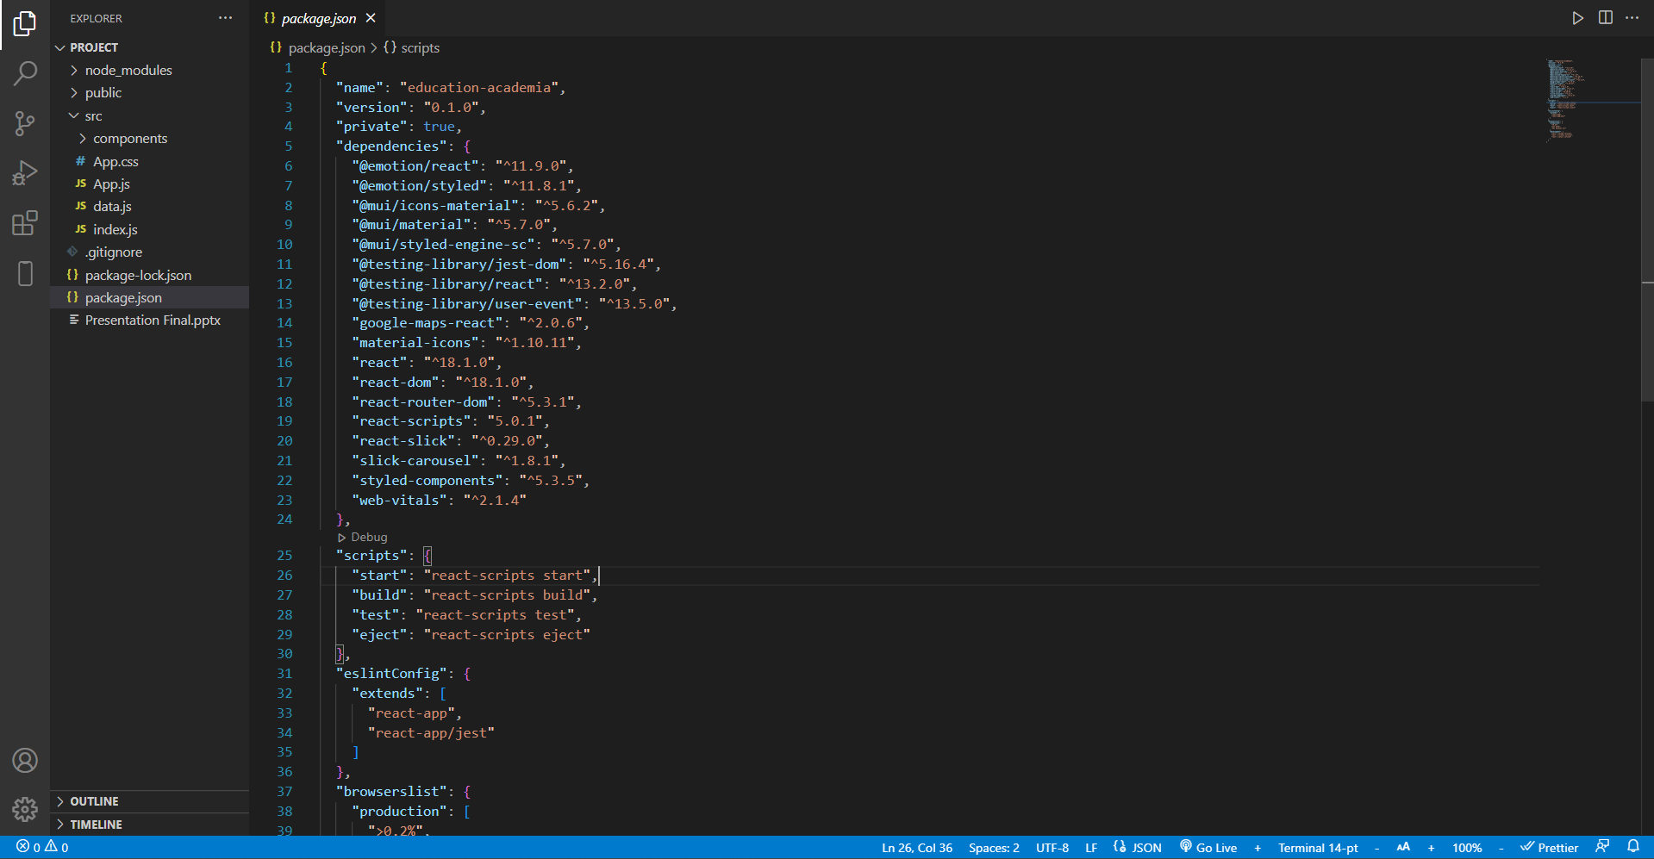

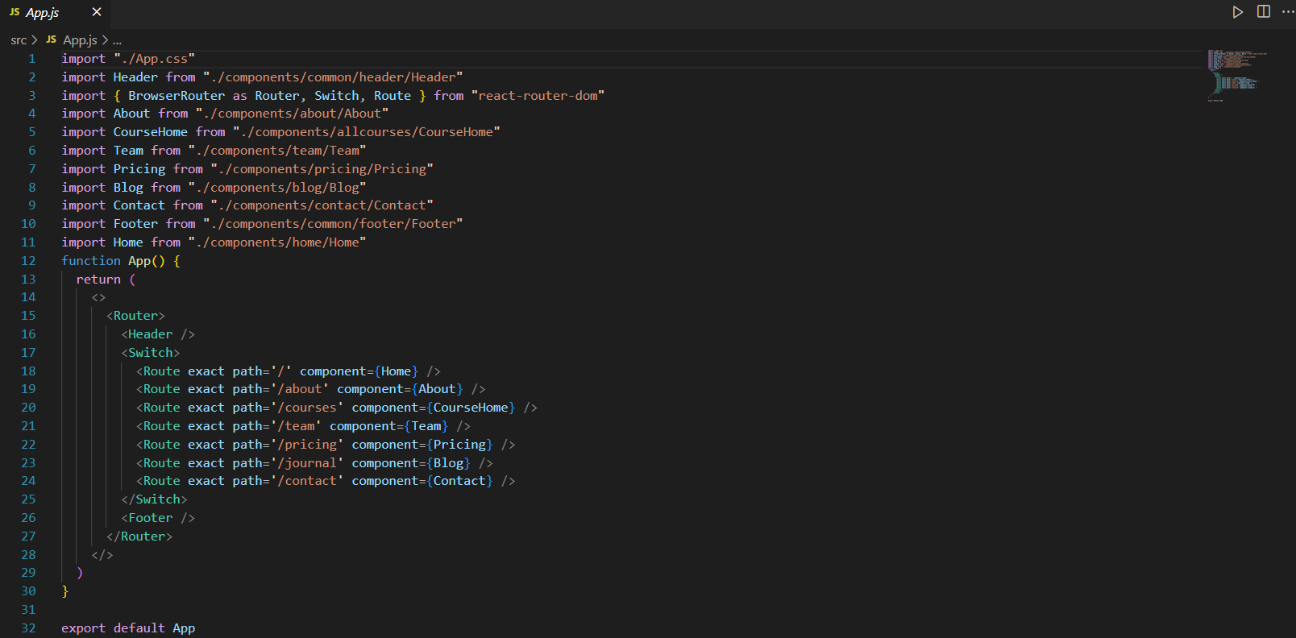

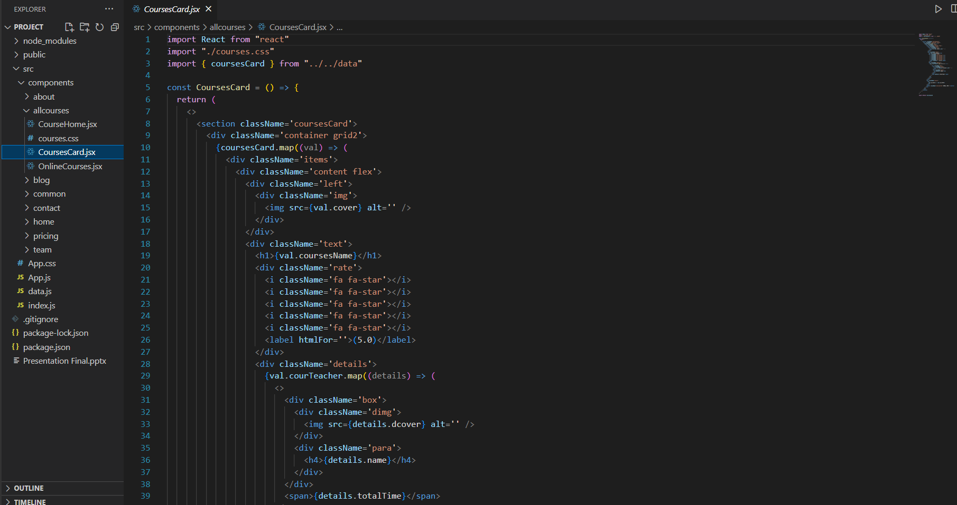

**Conclusion**

Learnify stands as a transformative solution in the field of digital education, addressing the critical challenges faced by traditional learning methods. By offering an engaging, personalized, and collaborative learning environment, it enhances student motivation and educational outcomes. The platform’s commitment to accessibility ensures that all students, regardless of their physical abilities, can benefit from its features. For educators, Learnify provides robust tools for efficient course management and real-time analytics, enabling data-driven decisions to support student success. Additionally, Learnify supports lifelong learning, catering to the needs of continuous education and skill development in an ever-evolving world. By leveraging advanced web technologies, Learnify ensures a secure, scalable, and adaptable platform, poised to meet the demands of modern education and beyond. In essence, Learnify bridges the gap between traditional education and the dynamic needs of today's learners, fostering a more inclusive, effective, and future-ready educational landscape.